Мальдивы
VIVANTA BY TAJ – CORAL REEF, MALDIVES 5*deluxe
Продолжительность: 10 ночей
Авиаперелёт А/К Emirates
3 разовое питание, полный пансион
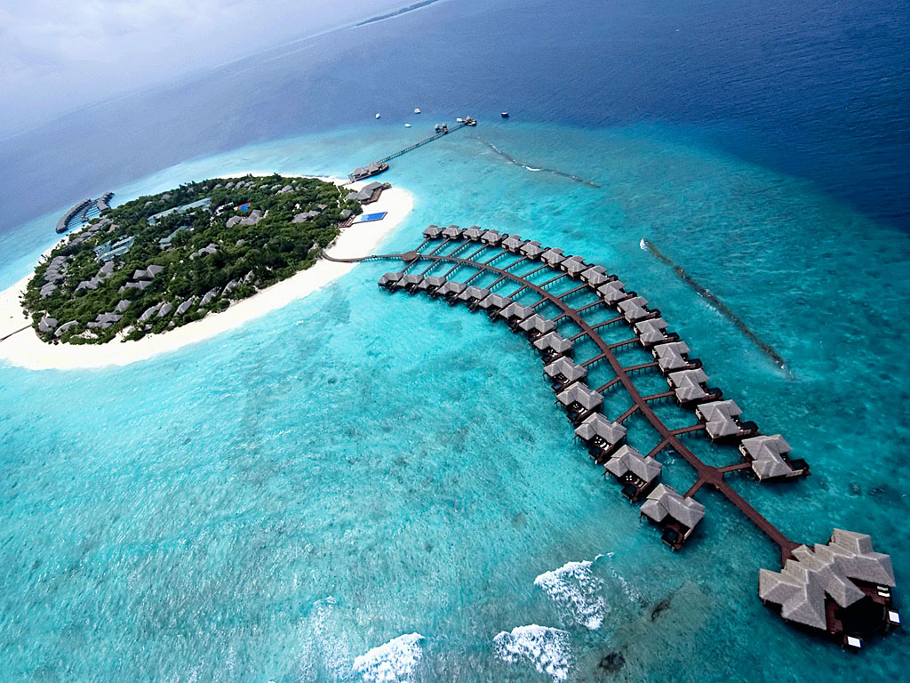
VIVANTA BY TAJ – CORAL REEF, MALDIVES 5*deluxe | FB | Charm - Beach Villa/DBL | 8727 USD | MDV-190-Emirates
VIVANTA BY TAJ – CORAL REEF, MALDIVES 5*deluxe | FB | Charm - Beach Villa/DBL | 8879 USD | MDV-190-Emirates
VIVANTA BY TAJ – CORAL REEF, MALDIVES 5*deluxe | FB | Charm - Beach Villa/DBL | 9033 USD | MDV-190-Emirates
VIVANTA BY TAJ – CORAL REEF, MALDIVES 5*deluxe | FB | Charm - Beach Villa/DBL | 9033 USD | MDV-190-Emirates
VIVANTA BY TAJ – CORAL REEF, MALDIVES 5*deluxe | FB | Charm - Beach Villa/DBL | 9033 USD | MDV-190-Emirates
VIVANTA BY TAJ – CORAL REEF, MALDIVES 5*deluxe | FB | Charm - Beach Villa/DBL | 9033 USD | MDV-190-Emirates
VIVANTA BY TAJ – CORAL REEF, MALDIVES 5*deluxe | FB | Charm - Beach Villa/DBL | 9033 USD | MDV-190-Emirates
VIVANTA BY TAJ – CORAL REEF, MALDIVES 5*deluxe | FB | Charm - Beach Villa/DBL | 9033 USD | MDV-190-Emirates
VIVANTA BY TAJ – CORAL REEF, MALDIVES 5*deluxe | FB | Charm - Beach Villa/DBL | 9033 USD | MDV-190-Emirates
VIVANTA BY TAJ – CORAL REEF, MALDIVES 5*deluxe | FB | Charm - Beach Villa/DBL | 9033 USD | MDV-190-Emirates
VIVANTA BY TAJ – CORAL REEF, MALDIVES 5*deluxe | FB | Charm - Beach Villa/DBL | 9033 USD | MDV-190-Emirates
VIVANTA BY TAJ – CORAL REEF, MALDIVES 5*deluxe | FB | Charm - Beach Villa/DBL | 9033 USD | MDV-190-Emirates
VIVANTA BY TAJ – CORAL REEF, MALDIVES 5*deluxe | FB | Charm - Beach Villa/DBL | 9033 USD | MDV-190-Emirates
VIVANTA BY TAJ – CORAL REEF, MALDIVES 5*deluxe | FB | Charm - Beach Villa/DBL | 9033 USD | MDV-190-Emirates
VIVANTA BY TAJ – CORAL REEF, MALDIVES 5*deluxe | FB | Charm - Beach Villa/DBL | 9033 USD | MDV-190-Emirates
VIVANTA BY TAJ – CORAL REEF, MALDIVES 5*deluxe | FB | Charm - Beach Villa/DBL | 9033 USD | MDV-190-Emirates
VIVANTA BY TAJ – CORAL REEF, MALDIVES 5*deluxe | FB | Charm - Beach Villa/DBL | 9033 USD | MDV-190-Emirates
VIVANTA BY TAJ – CORAL REEF, MALDIVES 5*deluxe | FB | Charm - Beach Villa/DBL | 9033 USD | MDV-190-Emirates
VIVANTA BY TAJ – CORAL REEF, MALDIVES 5*deluxe | FB | Charm - Beach Villa/DBL | 9033 USD | MDV-190-Emirates
VIVANTA BY TAJ – CORAL REEF, MALDIVES 5*deluxe | FB | Charm - Beach Villa/DBL | 9033 USD | MDV-190-Emirates
VIVANTA BY TAJ – CORAL REEF, MALDIVES 5*deluxe | FB | Charm - Beach Villa/DBL | 9033 USD | MDV-190-Emirates
VIVANTA BY TAJ – CORAL REEF, MALDIVES 5*deluxe | FB | Charm - Beach Villa/DBL | 9033 USD | MDV-190-Emirates
VIVANTA BY TAJ – CORAL REEF, MALDIVES 5*deluxe | FB | Charm - Beach Villa/DBL | 9033 USD | MDV-190-Emirates
VIVANTA BY TAJ – CORAL REEF, MALDIVES 5*deluxe | FB | Charm - Beach Villa/DBL | 9033 USD | MDV-190-Emirates
VIVANTA BY TAJ – CORAL REEF, MALDIVES 5*deluxe | FB | Charm - Beach Villa/DBL | 9033 USD | MDV-190-Emirates
VIVANTA BY TAJ – CORAL REEF, MALDIVES 5*deluxe | FB | Charm - Beach Villa/DBL | 9033 USD | MDV-190-Emirates
VIVANTA BY TAJ – CORAL REEF, MALDIVES 5*deluxe | FB | Charm - Beach Villa/DBL | 9033 USD | MDV-190-Emirates
VIVANTA BY TAJ – CORAL REEF, MALDIVES 5*deluxe | FB | Charm - Beach Villa/DBL | 9033 USD | MDV-190-Emirates
VIVANTA BY TAJ – CORAL REEF, MALDIVES 5*deluxe | FB | Charm - Beach Villa/DBL | 9033 USD | MDV-190-Emirates
VIVANTA BY TAJ – CORAL REEF, MALDIVES 5*deluxe | FB | Charm - Beach Villa/DBL | 9033 USD | MDV-190-Emirates
VIVANTA BY TAJ – CORAL REEF, MALDIVES 5*deluxe | FB | Charm - Beach Villa/DBL | 9033 USD | MDV-190-Emirates
VIVANTA BY TAJ – CORAL REEF, MALDIVES 5*deluxe | FB | Charm - Beach Villa/DBL | 9147 USD | MDV-190-Emirates
VIVANTA BY TAJ – CORAL REEF, MALDIVES 5*deluxe | FB | Delight - Deluxe Beach Villa/DBL | 9207 USD | MDV-190-Emirates
VIVANTA BY TAJ – CORAL REEF, MALDIVES 5*deluxe | FB | Charm - Beach Villa/DBL | 9235 USD | MDV-190-Emirates
VIVANTA BY TAJ – CORAL REEF, MALDIVES 5*deluxe | FB | Charm - Beach Villa/DBL | 9235 USD | MDV-190-Emirates
VIVANTA BY TAJ – CORAL REEF, MALDIVES 5*deluxe | FB | Charm - Beach Villa/DBL | 9235 USD | MDV-190-Emirates
VIVANTA BY TAJ – CORAL REEF, MALDIVES 5*deluxe | FB | Charm - Beach Villa/DBL | 9235 USD | MDV-190-Emirates
VIVANTA BY TAJ – CORAL REEF, MALDIVES 5*deluxe | FB | Charm - Beach Villa/DBL | 9235 USD | MDV-190-Emirates
VIVANTA BY TAJ – CORAL REEF, MALDIVES 5*deluxe | FB | Charm - Beach Villa/DBL | 9235 USD | MDV-190-Emirates
VIVANTA BY TAJ – CORAL REEF, MALDIVES 5*deluxe | FB | Charm - Beach Villa/DBL | 9235 USD | MDV-190-Emirates
VIVANTA BY TAJ – CORAL REEF, MALDIVES 5*deluxe | FB | Charm - Beach Villa/DBL | 9235 USD | MDV-190-Emirates
VIVANTA BY TAJ – CORAL REEF, MALDIVES 5*deluxe | FB | Charm - Beach Villa/DBL | 9235 USD | MDV-190-Emirates
VIVANTA BY TAJ – CORAL REEF, MALDIVES 5*deluxe | FB | Charm - Beach Villa/DBL | 9235 USD | MDV-190-Emirates
VIVANTA BY TAJ – CORAL REEF, MALDIVES 5*deluxe | FB | Delight - Deluxe Beach Villa/DBL | 9359 USD | MDV-190-Emirates
VIVANTA BY TAJ – CORAL REEF, MALDIVES 5*deluxe | FB | Delight - Deluxe Beach Villa/DBL | 9513 USD | MDV-190-Emirates
VIVANTA BY TAJ – CORAL REEF, MALDIVES 5*deluxe | FB | Delight - Deluxe Beach Villa/DBL | 9513 USD | MDV-190-Emirates
VIVANTA BY TAJ – CORAL REEF, MALDIVES 5*deluxe | FB | Delight - Deluxe Beach Villa/DBL | 9513 USD | MDV-190-Emirates
VIVANTA BY TAJ – CORAL REEF, MALDIVES 5*deluxe | FB | Delight - Deluxe Beach Villa/DBL | 9513 USD | MDV-190-Emirates
VIVANTA BY TAJ – CORAL REEF, MALDIVES 5*deluxe | FB | Delight - Deluxe Beach Villa/DBL | 9513 USD | MDV-190-Emirates
VIVANTA BY TAJ – CORAL REEF, MALDIVES 5*deluxe | FB | Delight - Deluxe Beach Villa/DBL | 9513 USD | MDV-190-Emirates
VIVANTA BY TAJ – CORAL REEF, MALDIVES 5*deluxe | FB | Delight - Deluxe Beach Villa/DBL | 9513 USD | MDV-190-Emirates
VIVANTA BY TAJ – CORAL REEF, MALDIVES 5*deluxe | FB | Delight - Deluxe Beach Villa/DBL | 9513 USD | MDV-190-Emirates
VIVANTA BY TAJ – CORAL REEF, MALDIVES 5*deluxe | FB | Delight - Deluxe Beach Villa/DBL | 9513 USD | MDV-190-Emirates
VIVANTA BY TAJ – CORAL REEF, MALDIVES 5*deluxe | FB | Delight - Deluxe Beach Villa/DBL | 9513 USD | MDV-190-Emirates
VIVANTA BY TAJ – CORAL REEF, MALDIVES 5*deluxe | FB | Delight - Deluxe Beach Villa/DBL | 9513 USD | MDV-190-Emirates
VIVANTA BY TAJ – CORAL REEF, MALDIVES 5*deluxe | FB | Delight - Deluxe Beach Villa/DBL | 9513 USD | MDV-190-Emirates
VIVANTA BY TAJ – CORAL REEF, MALDIVES 5*deluxe | FB | Delight - Deluxe Beach Villa/DBL | 9513 USD | MDV-190-Emirates
VIVANTA BY TAJ – CORAL REEF, MALDIVES 5*deluxe | FB | Delight - Deluxe Beach Villa/DBL | 9513 USD | MDV-190-Emirates
VIVANTA BY TAJ – CORAL REEF, MALDIVES 5*deluxe | FB | Delight - Deluxe Beach Villa/DBL | 9513 USD | MDV-190-Emirates
VIVANTA BY TAJ – CORAL REEF, MALDIVES 5*deluxe | FB | Delight - Deluxe Beach Villa/DBL | 9513 USD | MDV-190-Emirates
VIVANTA BY TAJ – CORAL REEF, MALDIVES 5*deluxe | FB | Delight - Deluxe Beach Villa/DBL | 9513 USD | MDV-190-Emirates
VIVANTA BY TAJ – CORAL REEF, MALDIVES 5*deluxe | FB | Delight - Deluxe Beach Villa/DBL | 9513 USD | MDV-190-Emirates
VIVANTA BY TAJ – CORAL REEF, MALDIVES 5*deluxe | FB | Delight - Deluxe Beach Villa/DBL | 9513 USD | MDV-190-Emirates
VIVANTA BY TAJ – CORAL REEF, MALDIVES 5*deluxe | FB | Delight - Deluxe Beach Villa/DBL | 9513 USD | MDV-190-Emirates
VIVANTA BY TAJ – CORAL REEF, MALDIVES 5*deluxe | FB | Delight - Deluxe Beach Villa/DBL | 9513 USD | MDV-190-Emirates
VIVANTA BY TAJ – CORAL REEF, MALDIVES 5*deluxe | FB | Delight - Deluxe Beach Villa/DBL | 9513 USD | MDV-190-Emirates
VIVANTA BY TAJ – CORAL REEF, MALDIVES 5*deluxe | FB | Delight - Deluxe Beach Villa/DBL | 9513 USD | MDV-190-Emirates
VIVANTA BY TAJ – CORAL REEF, MALDIVES 5*deluxe | FB | Delight - Deluxe Beach Villa/DBL | 9513 USD | MDV-190-Emirates
VIVANTA BY TAJ – CORAL REEF, MALDIVES 5*deluxe | FB | Delight - Deluxe Beach Villa/DBL | 9513 USD | MDV-190-Emirates
VIVANTA BY TAJ – CORAL REEF, MALDIVES 5*deluxe | FB | Delight - Deluxe Beach Villa/DBL | 9513 USD | MDV-190-Emirates
VIVANTA BY TAJ – CORAL REEF, MALDIVES 5*deluxe | FB | Delight - Deluxe Beach Villa/DBL | 9513 USD | MDV-190-Emirates
VIVANTA BY TAJ – CORAL REEF, MALDIVES 5*deluxe | FB | Delight - Deluxe Beach Villa/DBL | 9513 USD | MDV-190-Emirates
VIVANTA BY TAJ – CORAL REEF, MALDIVES 5*deluxe | FB | Delight - Deluxe Beach Villa/DBL | 9513 USD | MDV-190-Emirates
VIVANTA BY TAJ – CORAL REEF, MALDIVES 5*deluxe | FB | Delight - Deluxe Beach Villa/DBL | 9567 USD | MDV-190-Emirates
VIVANTA BY TAJ – CORAL REEF, MALDIVES 5*deluxe | FB | Delight - Deluxe Beach Villa/DBL | 9715 USD | MDV-190-Emirates
VIVANTA BY TAJ – CORAL REEF, MALDIVES 5*deluxe | FB | Delight - Deluxe Beach Villa/DBL | 9715 USD | MDV-190-Emirates
VIVANTA BY TAJ – CORAL REEF, MALDIVES 5*deluxe | FB | Delight - Deluxe Beach Villa/DBL | 9715 USD | MDV-190-Emirates
VIVANTA BY TAJ – CORAL REEF, MALDIVES 5*deluxe | FB | Delight - Deluxe Beach Villa/DBL | 9715 USD | MDV-190-Emirates
VIVANTA BY TAJ – CORAL REEF, MALDIVES 5*deluxe | FB | Delight - Deluxe Beach Villa/DBL | 9715 USD | MDV-190-Emirates
VIVANTA BY TAJ – CORAL REEF, MALDIVES 5*deluxe | FB | Delight - Deluxe Beach Villa/DBL | 9715 USD | MDV-190-Emirates
VIVANTA BY TAJ – CORAL REEF, MALDIVES 5*deluxe | FB | Delight - Deluxe Beach Villa/DBL | 9715 USD | MDV-190-Emirates
VIVANTA BY TAJ – CORAL REEF, MALDIVES 5*deluxe | FB | Delight - Deluxe Beach Villa/DBL | 9715 USD | MDV-190-Emirates
VIVANTA BY TAJ – CORAL REEF, MALDIVES 5*deluxe | FB | Delight - Deluxe Beach Villa/DBL | 9715 USD | MDV-190-Emirates
VIVANTA BY TAJ – CORAL REEF, MALDIVES 5*deluxe | FB | Delight - Deluxe Beach Villa/DBL | 9715 USD | MDV-190-Emirates
VIVANTA BY TAJ – CORAL REEF, MALDIVES 5*deluxe | FB | Charm - Beach Villa/DBL | 9875 USD | MDV-190-Emirates
VIVANTA BY TAJ – CORAL REEF, MALDIVES 5*deluxe | FB | Charm - Beach Villa/DBL | 9917 USD | MDV-190-Emirates
VIVANTA BY TAJ – CORAL REEF, MALDIVES 5*deluxe | FB | Indulgence - Deluxe Water Villa/DBL | 10023 USD | MDV-190-Emirates
VIVANTA BY TAJ – CORAL REEF, MALDIVES 5*deluxe | FB | Charm - Beach Villa/DBL | 10037 USD | MDV-190-Emirates
VIVANTA BY TAJ – CORAL REEF, MALDIVES 5*deluxe | FB | Charm - Beach Villa/DBL | 10133 USD | MDV-190-Emirates

